Relationships in UML: the Lab 8 system
Visual UML Class Diagram (matching lecture slide format):
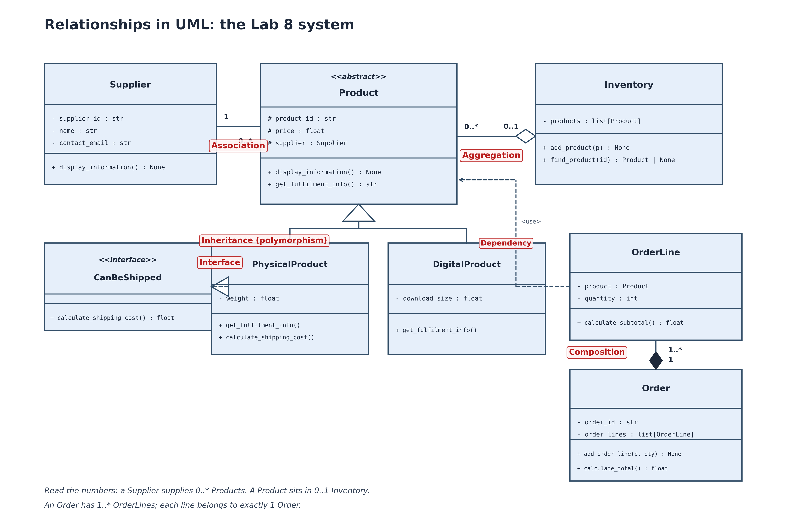

Classes and Methods Breakdown
Class Supplier
- supplier_id : str
- name : str
- contact_email : str
+ display_information() : None
<<abstract>> Class Product (ABC)
# product_id : str
# price : float
# supplier : Supplier
+ display_information() : None
+ get_fulfilment_info() : str <<abstract>>
<<interface>> Class CanBeShipped (ABC)
+ calculate_shipping_cost() : float
Class PhysicalProduct (extends Product, implements CanBeShipped)
- weight : float
+ get_fulfilment_info() : str
+ calculate_shipping_cost() : float
Class DigitalProduct (extends Product)
- download_size : float
+ get_fulfilment_info() : str
Class Inventory
- products : list[Product]
+ add_product(p: Product) : None
+ find_product(id: str) : Product | None
+ remove_product(id: str) : bool
+ display_all() : None
Class OrderLine
- product : Product
- quantity : int
+ calculate_subtotal() : float
Class Order
- order_id : str
- order_lines : list[OrderLine]
+ add_order_line(p: Product, qty: int) : None
+ calculate_total() : float

Relationships and UML Notations (Lab 8 Brief Section 8)
1. Association (Supplier 1 --- 0..* Product):
A loose "knows-about" relationship with no whole-part ownership. A Supplier supplies 0..* Products, and each Product refers to 1 Supplier. Represented by a solid line with multiplicity numbers.
2. Aggregation (Inventory 0..1 <>--- 0..* Product):
A "has-a" whole-part relationship with weak ownership. A Product sits in 0..1 Inventory at a time, and an Inventory aggregates 0..* Products. If an Inventory is emptied, the Product objects are not destroyed. Represented by a solid line with a hollow diamond at the Inventory end.
3. Inheritance / Polymorphism (PhysicalProduct, DigitalProduct ---> Product):
An "is-a" relationship where subclasses inherit common attributes and methods from the abstract Product base class. Subclasses override get_fulfilment_info() and display_information(). Represented by solid lines with a hollow triangle pointing up to Product.
4. Interface Realisation (PhysicalProduct ---> CanBeShipped):
A "must-be-able-to" contract. PhysicalProduct implements calculate_shipping_cost(). Represented by a dashed line with a hollow triangle pointing to CanBeShipped.
5. Composition (Order 1 <filled-diamond>--- 1..* OrderLine):
A terminal whole-part relationship with strong lifecycle ownership. An Order creates and manages its own OrderLine objects. If the Order is destroyed, its OrderLines are destroyed with it. Represented by a solid line with a filled black diamond at the Order end.
6. Dependency (OrderLine ---> Product):
An OrderLine refers to and uses a Product to query its price and name without owning it. Represented by a dashed arrow pointing from OrderLine to Product labeled <use>.

